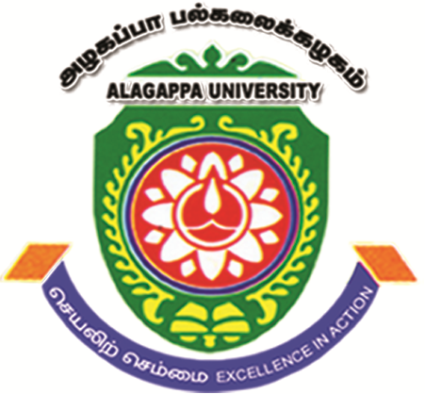 ALAGAPPA UNIVERSITY 
(A State University Reaccredited with “A” by NAAC)
Karaikudi – 630 003
ALAGAPPA INSTITUTE OF MANAGEMENT
Dr. P. S. NAGARAJAN September 05, 2012.
Assistant Professor

Selection of Project Fellow for UGC Major Research Project
Applications are invited from the eligible candidates for the post of Project Fellow to work in a major Research Project on “ A Study on Enhancing the Marketing of Self Help Group Products in Select Districts of Tamil Nadu” sponsored by the University Grants Commission (UGC). The interested candidates with the following qualifications are requested to send their Bio-data with the essential attested copies of certificates to the below mentioned address on or before 20th September 2012.

Project Fellow | Number Of Position: One
Project Fellow | Salary Per Month: Rs. 14000/-
Project Fellow | Duration: 18 Months
Project Fellow | Essential Qualification: Master Of Business Administration
Project Fellow | Desirable Qualification: M.Phil in Management.

NOTE
- No TA/DA will be paid for attending the interview.
- Date of Interview and venue will be intimated later.
Address for Communication
Dr. P. S. Nagarajan
Principal Investigator – UGC Major Research Project
Assistant Professor
Alagappa Institute of Management, Karaikudi - 630003
Mobile: 9444061581, 9626912356
E-mail: nagashan@rediffmail.com

